* Enter the following connection details:

|  |  |
| --- | --- |
| **Connection Name:** | sys - OPCDBCS |
| **Username:** | sys |
| **Password:** | Alpha2014_ |
| **Check:** | “Save Password” |
| **Connection Type:** | SSH |
| **Role:** | SYSDBA |
| **Service Name:** | ORCL.<Your Domain ID>.oraclecloud.internal |

***Note:*** *You can optionally select a color for the connection to differentiate it from other connections.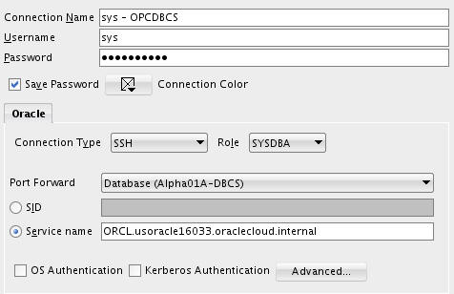*

* Click Test to confirm the information was entered correctly. Verify that you receive a ‘Success’ status.

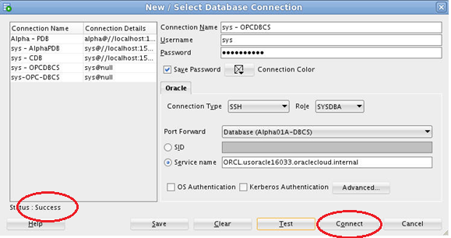

* Click Connect to save the connection information which opens a new SQL Worksheet.

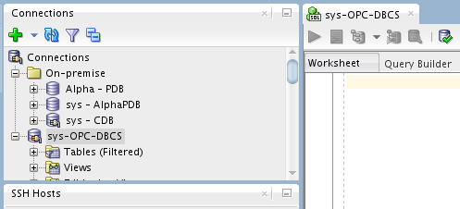

#### Copy the Clone Pluggable Database to the Cloud

In this step we will copy the cloned pluggable database to the cloud using SQL Developer.

* Click on View🡪Task Progress to open up the Task Progress window.
* In the DBA window expand ‘**sys – CDB**’ and expand ‘**Container Database**’, then right-click on ALPHACLONE and select “Clone PDB to Oracle Cloud”

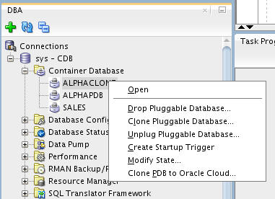

* Nothing needs to be changed in this window, verify that the default properties include your Public Cloud Connection. Click Apply.
* Source PDB: ALPHACLONE
* Destination Connection: sys - OPCDBCS
* Action after clone: RePlug

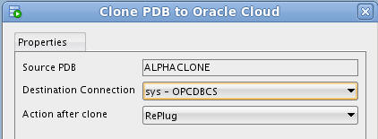

* You will note in the Task Progress window the progress of moving the datafiles over to the cloud database. This task will take about a minute to complete.

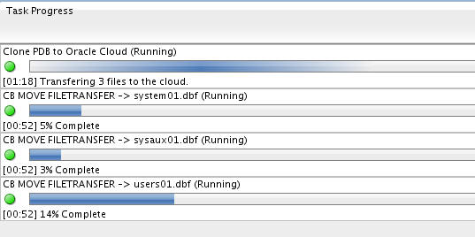

* Upon completion of the transfer you will be alerted to at least two Plugin Violations. This is because the patch level of the local ALPHACLONE pluggable database is different than the Container database in the cloud. We will remedy this in the next few steps.
* Click **OK** for **each** popup.

**Note:** The datafiles will be transferred despite what the pop up implies.

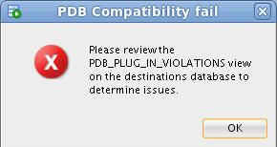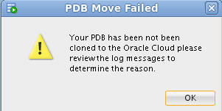

#### Use EM Express to plug the transferred database

* Open Chrome by clicking the icon on the menu bar or the Desktop.



* Enter the following URL into the Address bar or click the "EM Express - DB" link in the header bar – **https://localhost:5500/em**

**Note:** When using localhost:5500 in the URL below, your browser request is routed through the SSH proxy that we loaded in a terminal window in the first lab. If for some reason that window was closed, or is not working, you should refer to the first lab in step 1.6.2



* Enter the following login credentials, check the "as sysdba" box and click the Login button:

|  |  |
| --- | --- |
| **User Name:** | sys |
| **Password:** | Alpha2014_ |
| **Check:** | as sysdba |

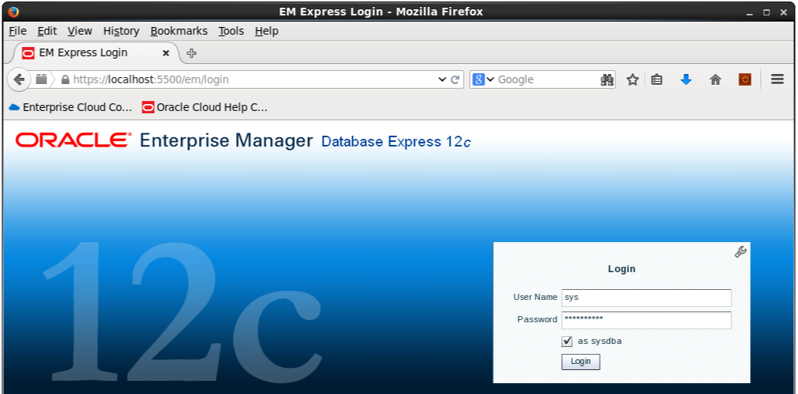

* We will now plug the Alpha Clone database into the Cloud database. From the Database Home page, click the CDB(1 PDBs) link.

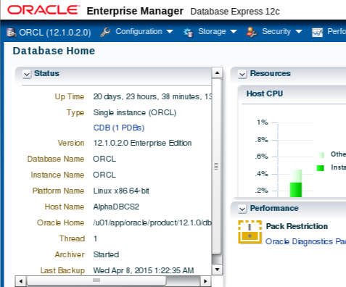

* Open the Actions list and select the Plug command

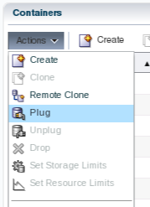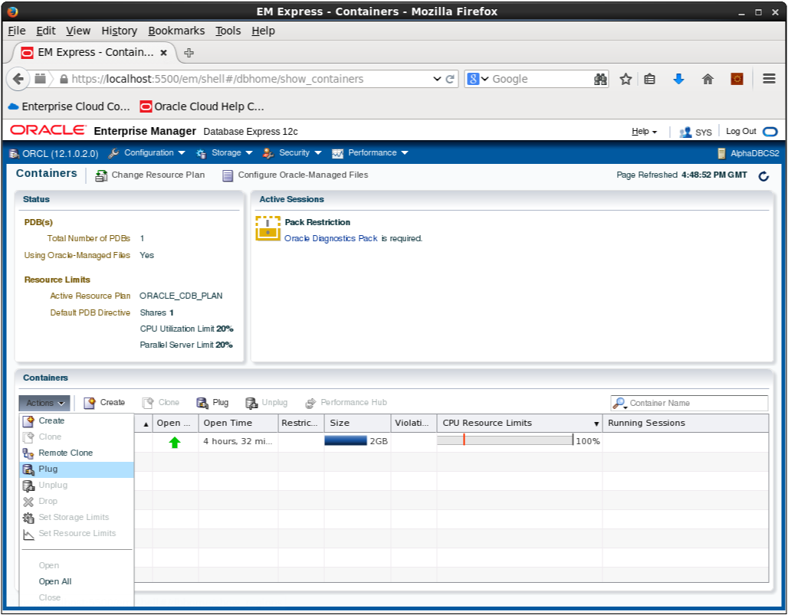

* Enter the following filename and directory location in the Metadata File field in the Plug PDB dialog box.

Metadata File: **/u02/app/oracle/oradata/ORCL/ALPHACLONE/ALPHACLONE.XML**

* **Uncheck** the **Reuse source datafile location from Metadata File** check box
* Enter the Source Datafile Location:

Source Datafile Location: **/u02/app/oracle/oradata/ORCL/ALPHACLONE**

* Click OK

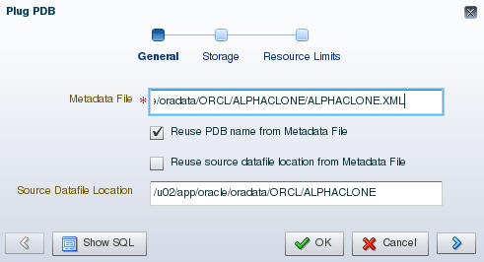

* The Processing message displays for the 2 minutes (approximately) required to plug the database into the container. Click the OK button when the Confirmation message displays.

|  |  |  |
| --- | --- | --- |
|  |  |  |

* Notice the database is now in the list of Containers**.**

**Note: There will be Violations because of the patch level mismatch between the original source Pluggable database and the Cloud Container database**.

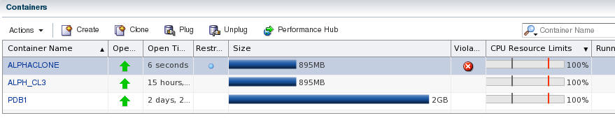

* You now need to SSH into the Cloud database server in order to patch the database. Example is shown below. Substitute your Cloud database server IP address (Alpha01A-DBCS)
* Open a Terminal and type the following SSH command to connect to the cloud database server.
* ssh -o ServerAliveInterval=60 -i /u01/OPCWorkshop/lab/labkey oracle@<Alpha01A-DBCS-IP-address>

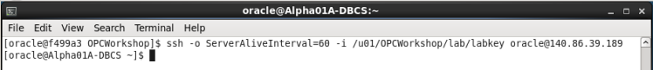

* We’ll need to run the datapatch script to apply any missing patches. It should run with no errors.

**Note: If it complains the first time about not being able to determine the current opatch status then wait a minute until it’s had time to pick up the newly cloned pluggable database and retry.**

* $ORACLE_HOME/OPatch/datapatch -verbose

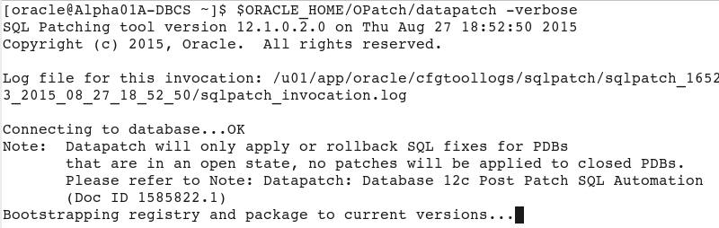

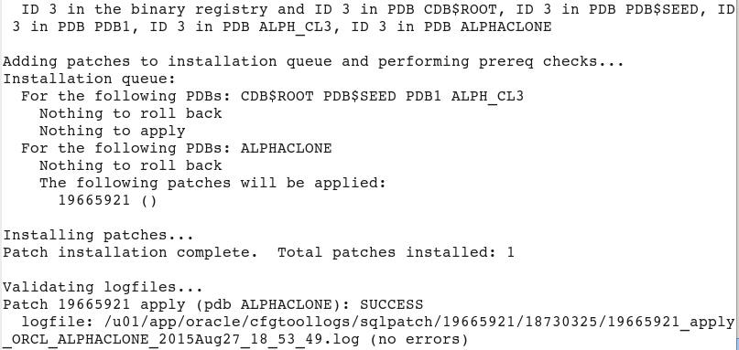

In the next few steps we’ll upgrade the PDB.

**Note:** If you receive an error message like, “The pluggable databases that need to be patched must be in upgrade mode” complete the following upgrade PDB Step. If not, proceed directly to the next step (Close and Reopen ALPHACLONE PDB).

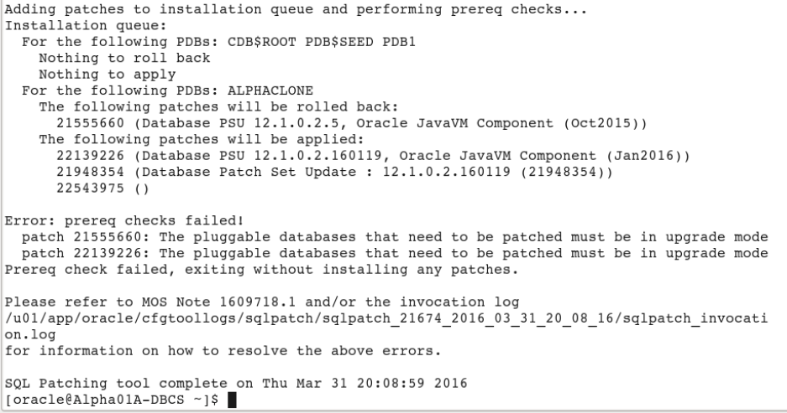

* Put the database in upgrade mode to correct the patch errors.
* Connect to container database using SQL Plus and place the database in upgrade mode. Once completed run datapatch again and you should have no errors. Run the following commands to complete this step.
* sqlplus / as sysdba
* alter pluggable database ALPHACLONE close;
* alter pluggable database ALPHACLONE open upgrade;
* exit
* $ORACLE_HOME/OPatch/datapatch -verbose

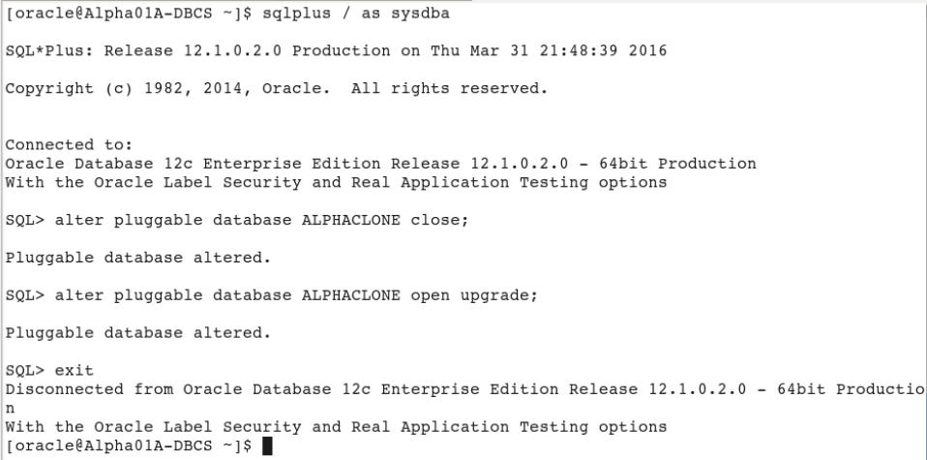

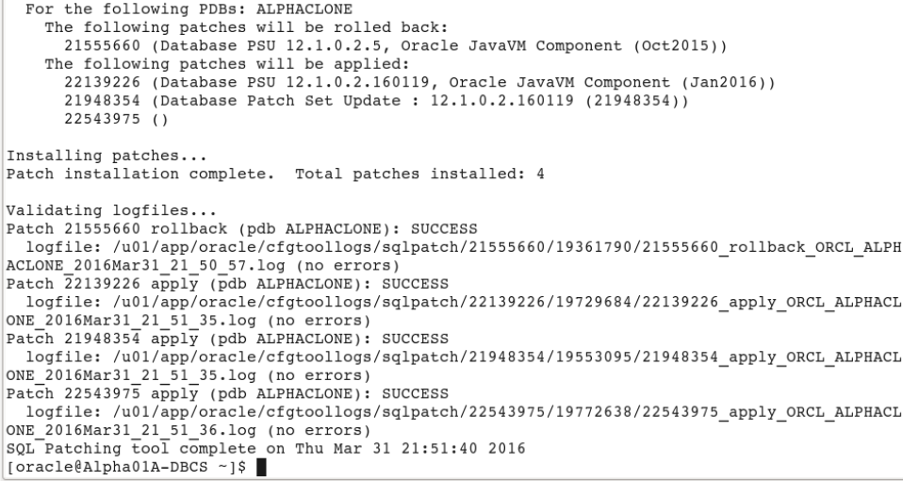

* **Close and Reopen ALPHACLONE PDB**
* The final step is to close and reopen the ALPHACLONE pluggable database. Go back to EM Express, with the ALPHACLONE row highlighted. (DO NOT CLICK THE ALPHACLONE LINK).
* Select **Actions 🡪 Close**.